Project Design Phase-II
Technology Stack (Architecture & Stack)

Date | 15 March 2025
Team ID | SWTID1743498710
Project Name | I-Movies: Movie Ticket Booking System
Maximum Marks | 4 Marks

Technical Architecture:

Guidelines :
- All processes included: Components like user interaction, business logic, APIs, storage, and deployment infrastructure are covered below.
- Infrastructural demarcation: Local systems vs Cloud platforms clearly separated.
- External interfaces: APIs like Aadhar or third-party services included.
- Data Storage components: Local and cloud databases, file storage

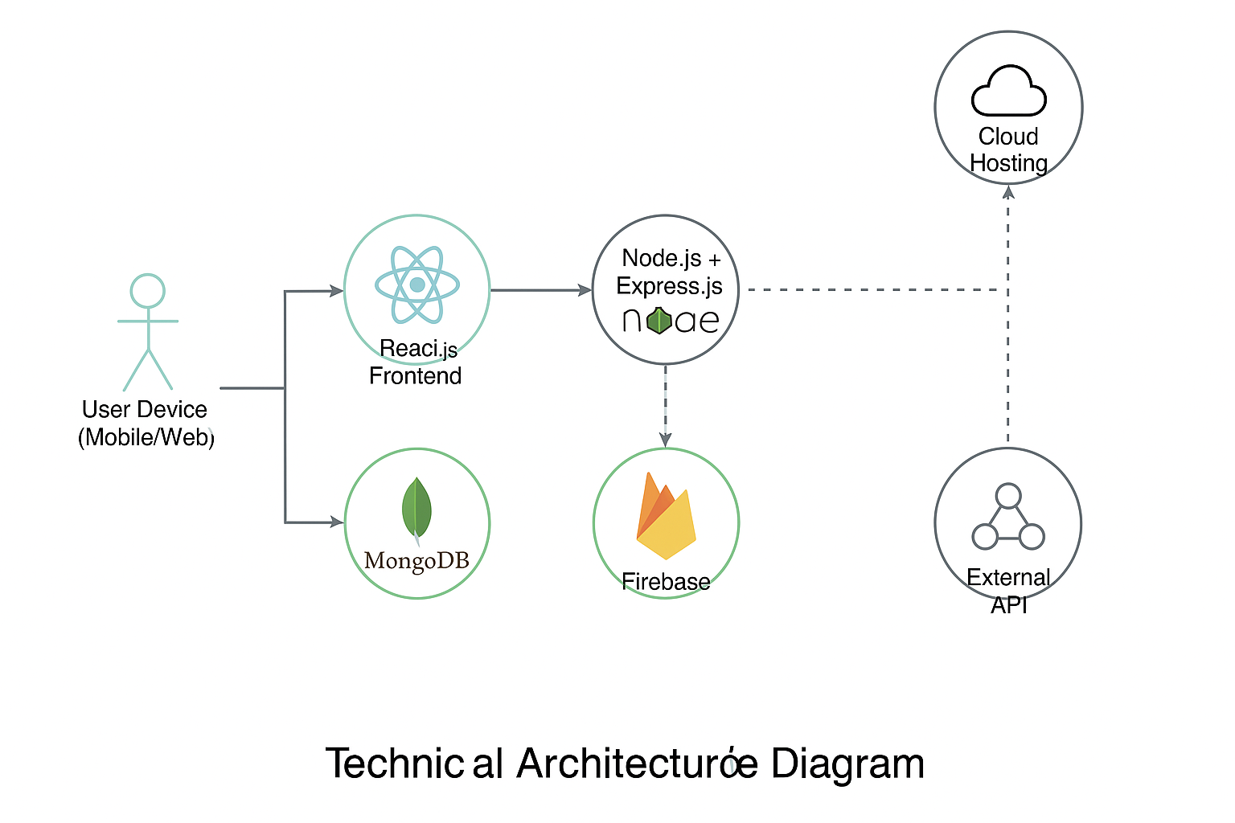

S.No | Component | Description | Technology
 | User Interface | How user interacts with application e.g.  Web UI, Mobile App, Chatbot etc. | HTML, CSS, JavaScript, React.js / Angular.js, Bootstrap.
 | Application Logic-1 | Logic for a process in the application | Node.js / Java / Python (Express, Flask, or Spring Boot)
 | Application Logic-2 | Logic for a process in the application | IBM Watson Speech-to-Text, Google STT API
 | Application Logic-3 | Logic for a process in the application | IBM Watson Assistant, Dialogflow
 | Database | Data Type, Configurations etc. | MongoDB, MySQL
 | Cloud Database | Database Service on Cloud | Firebase Realtime DB, IBM Cloudant, IBM DB2
 | File Storage | File storage requirements | Firebase Storage, IBM Block Storage, AWS S3
 | External API-1 | Purpose of External API used in the application | IBM Weather API
 | External API-2 | Purpose of External API used in the application | UIDAI Aadhar API, Gov Auth services
 | Machine Learning Model | Purpose of Machine Learning Model | OpenCV, TensorFlow Lite, YOLO, IBM Watson Visual Recognition
 | Infrastructure (Server / Cloud) | Application Deployment on Local System / Cloud  Local Server Configuration:  Cloud Server Configuration : | Local Server, IBM Cloud, Cloud Foundry, Kubernetes, Docker, CI/CD pipeline

Table-2: Application Characteristics:
S.No | Characteristics | Description | Technology
 | Open-Source Frameworks | List the open-source frameworks used | React.js, Node.js, Express.js, Flask, Bootstrap, MongoDB
 | Security Implementations | List all the security / access controls implemented, use of firewalls etc. | JWT, SHA-256, OAuth2, HTTPS, Firewalls, IAM, OWASP Guidelines
 | Scalable Architecture | Justify the scalability of architecture (3 – tier, Micro-services) | REST API, Docker, Kubernetes, Load Balanced Services
 | Availability | Justify the availability of applications (e.g. use of load balancers, distributed servers etc.) | Load Balancer (NGINX), Replicated DB, Backup System, Horizontal Scaling
 | Performance | Design consideration for the performance of the application (number of requests per sec, use of Cache, use of CDN’s) etc. | Redis Cache, CDN (Cloudflare), Indexed DB, Connection Pooling

